A. Add New Book
- Function: Allows staff to input a new book into the system.
- Details: Staff enter ISBN, title, author, publisher, category, edition. The system automatically generates associated book copies.
- Module: Books
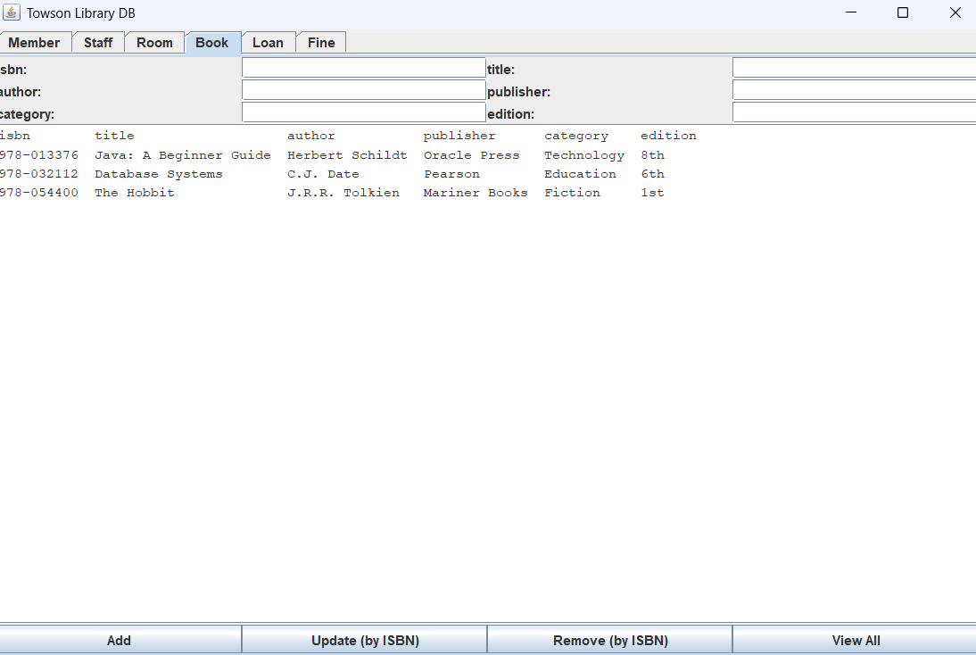

B. Add New Member
- Function: Registers a new library member.
- Details: Required fields include first name, last name, email, and membership type.
- Module: Members
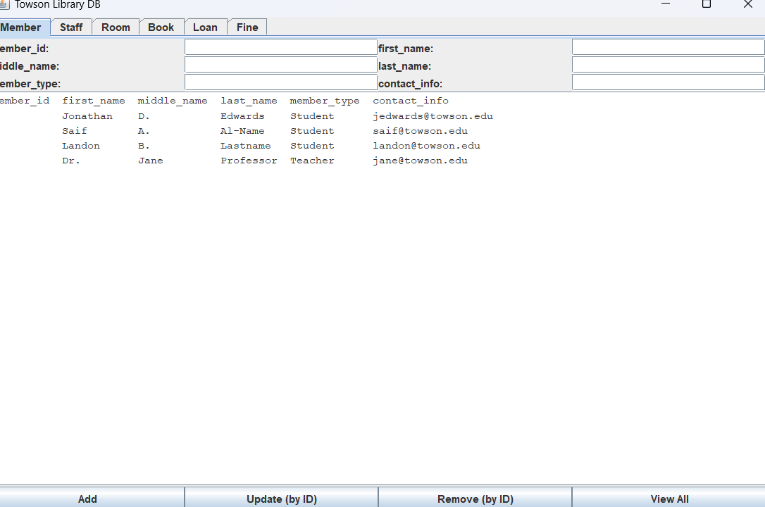

C. Fines
- Function: Displays outstanding and resolved fines for members.
- Details: Fines are automatically created when loans exceed due dates. Shows fine id, loan id, amount, status, applied date
- Module: Fines
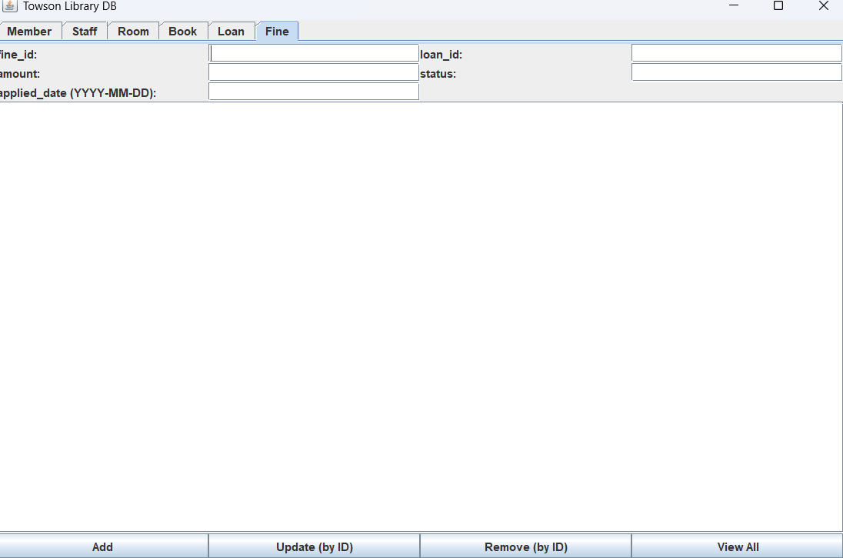

D. Loans (Borrowing System)
- Function: Manages book borrowing and returning.
- Details: Staff can issue books, return books, and view borrowing history. It shows the loan id, member id, issue date, isbn, due date, and return date.
- Module: Loans
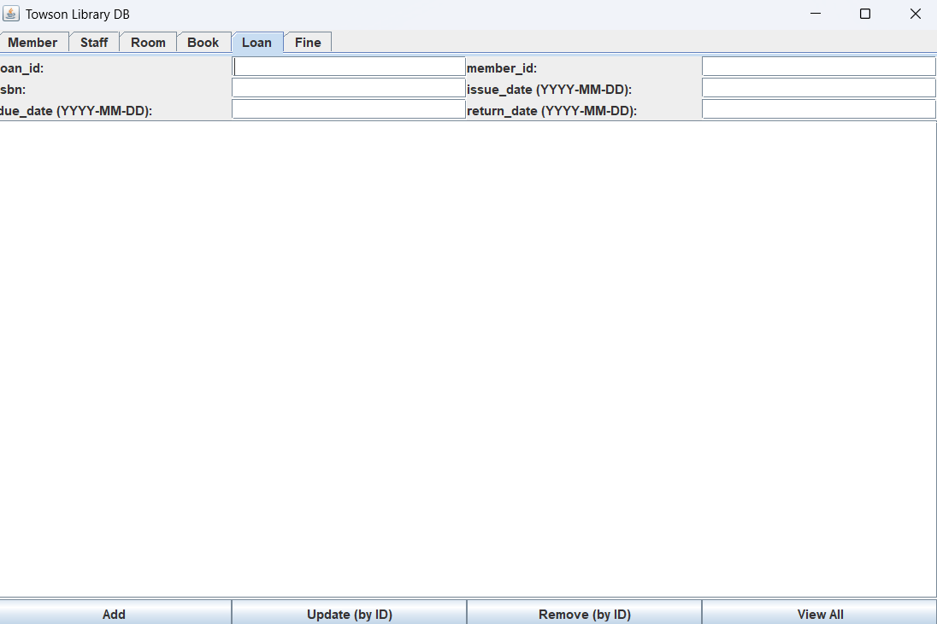

E. Login Page
- Function: User authentication for accessing the library system.
- Details: Currently checks credentials then makes you enter into SQL data base. credentials securely and encrypt passwords.
- Module: Security
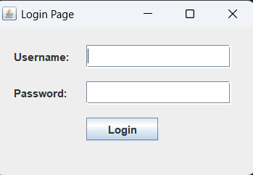
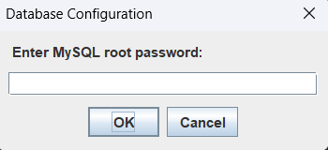

F. Staff
- Function: To show all staff information
- Details: Shows staff id, first and last names, and their contact information.
- Module: System Reports
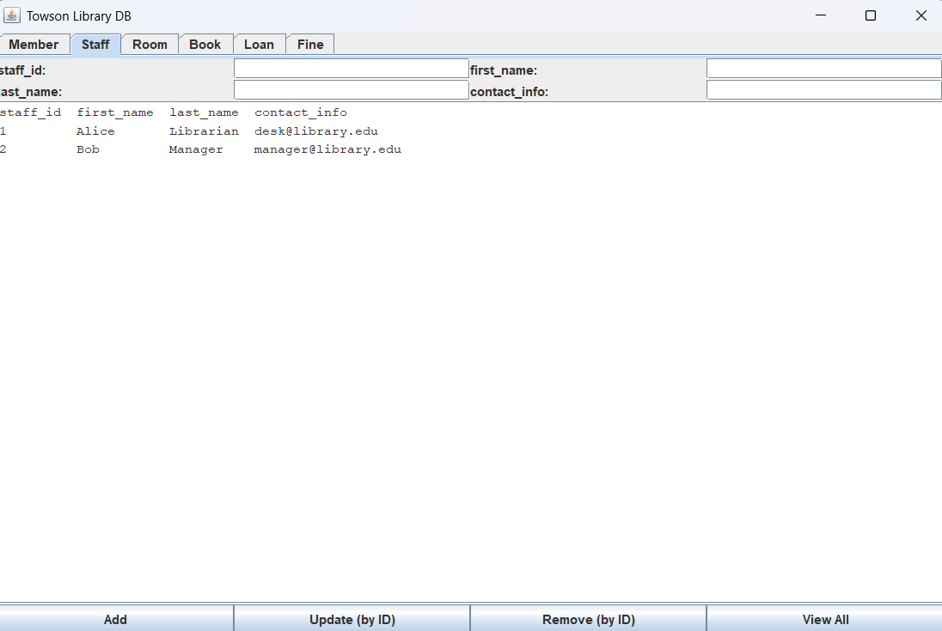

G. Room
- Function: Shows information on all the rooms in the library.
- Details: Shows room id, room name, and the capacity
- Module: System Reports
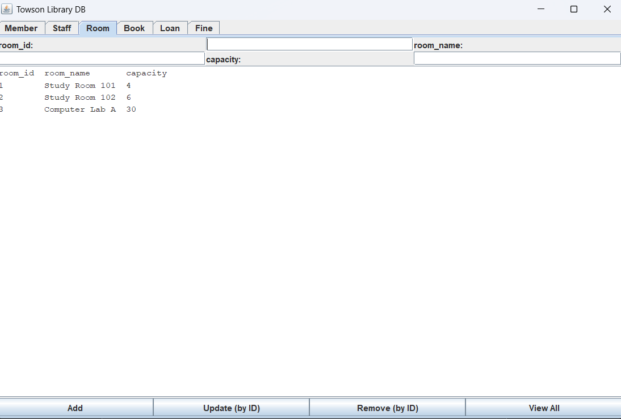

H. View Books Table
- Function: Displays a list of all books in the library system.
- Details: Includes ISBN, title, author, genre, and availability. Search and filtering tools help with navigation.
- Module: Books
